1. **Most flown route (to and fro)**
2. 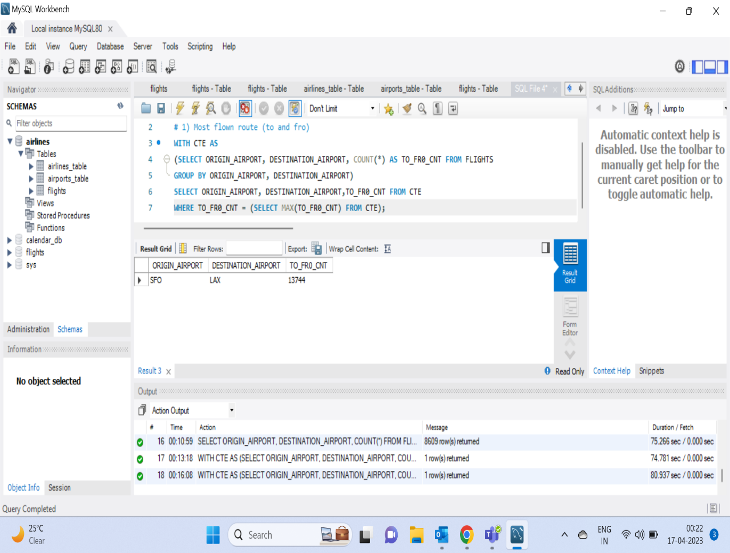

2)  **Airlines with most cancellation or deviation**

1. **Busiest hour of the day when flights take off**

